**Spesifikasi Kemasan**

**Nama Produk :** ZOI Faraday Series Ceiling Pendant Electromagnetic Double Arm For

Surgical

**Tipe :** ZOI-CP-FM-1200

1. **Label**
   1. Label penandaan ZOI Faraday Series Ceiling Pendant Electromagnetic Double Arm For Surgical

* Bahan : Stiker Vinyl
* Warna Label : Putih
* Warna Teks : Hitam
* Ukuran : 90 x 60 mm (p x l)

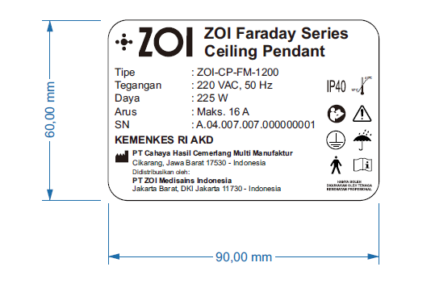

Gambar 1. Label Penandaan ZOI Faraday Series Ceiling Pendant Electromagnetic Double Arm For Surgical

1. **Kemasan**
   1. Wooden Box ZOI Faraday Series Ceiling Pendant Electromagnetic Double Arm For Surgical
      * Bahan : Kayu
      * Bentuk : Kotak
      * Warna : Natural/kayu/Coklat
      * Ukuran : 220 x 55 x 65 cm (p x l x t)

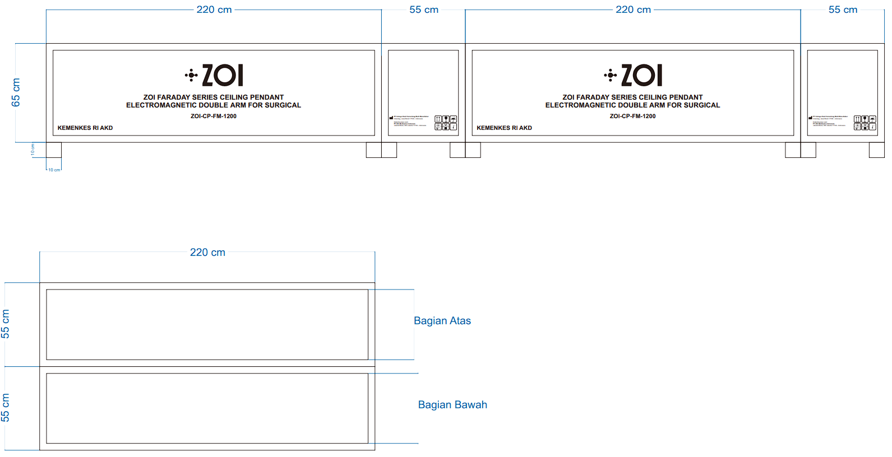

Gambar 2. Wooden Box ZOI Faraday Series Ceiling Pendant Electromagnetic Double Arm For Surgical